Trap Lines
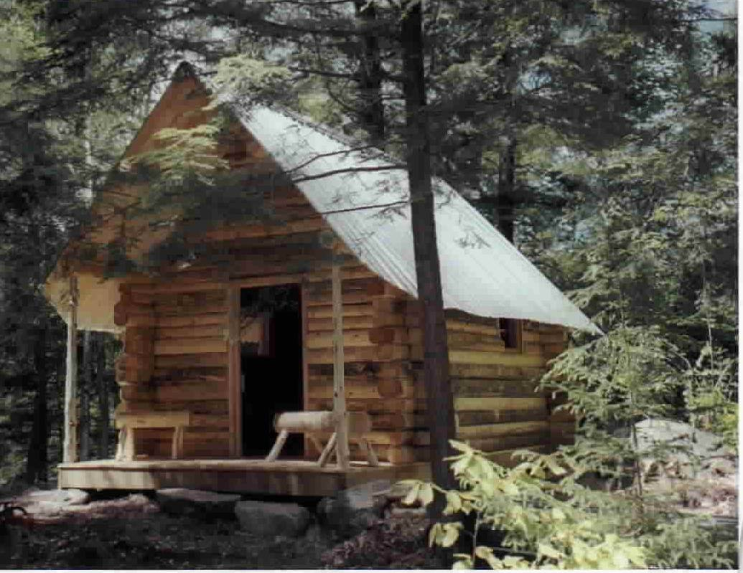
The new Trapper Cabin
At the Owl Brook Center
August 2004
by Mel Liston
Strafford, New Hampshire
New Hampshire Trappers Gathering
Fall is in the air and once again Twenty-First century hunters and trappers will wander into Mother Nature’s back yard to enjoy the timeless beauty and endless mysteries that are presented for mortals to ponder. Mankind is forever bound to the natural order of things even though so-called modern man is somewhat removed from this truth and often estranged from its reality. There are those among us, for whom circumstances have allowed an opportunity to be near the rural and wild places. Many strongly feel the primordial genetic draw to be a functioning part of the natural world. By this I mean we feel a desire to provide in some small way for our consumptive need via a harvest from the annual renewable abundance in Mother Nature’s storehouse. We all are forced to function within artificial or greatly altered environments. We are consumed by man-made smells and sounds. We travel at great speed over concrete or pavement generally only looking at the very edge of the natural area, which hints at what lies beyond. The time spent venturing beyond the edge invigorates those of us who experience some of what is there. From taking photographs of natural beauty it’s only a small leap of understanding and connection to begin collecting evergreen cones, old birds nests, rocks, antlers, etc. with appreciation of their beauty and to bring tokens of nature into our otherwise unnatural lives. Some will view these tokens often for the natural psychological connection they provide and others will include them in their crafts to enhance innate beauty with an additional display of love for nature, which is the essence of our heart and soul. To be in the natural world and not partake of the wild berries, apples, mushrooms, roots, and other foods, of which we have knowledge, is difficult to contemplate. Gathering firewood for the winter’s heat warms us in more ways than one. All of these personally gathered products from nature for our consumptive use allow us to step outside the modern system of things even if only for a temporary experience. We are only doing what is genetically natural and comfortable. It gives us pleasure to connect our present with the antiquity of the past in a natural way and allows for a deeper understanding and appreciation of who we are and have always been. It is a small step from being a natural gatherer to being a hunter or trapper. The same genetic needs and desires lead to this level of involvement within nature when the opportunity is available. All of these groups wherever they are along in this progression of opportunity have the welfare of their beloved natural treasures at heart. All who are connected are intimately involved with the natural order and will look to the stewardship of Mother Nature’s abundance.
And so it is, that the like minded among us, who have experienced and enjoyed the natural involvement of being a fur trapper will come together for an annual event to discuss, display, and otherwise exhibit our inclination toward and share our experiences of this continuing and worthwhile avocation. The New Hampshire Trappers Association will be holding it’s Fifty-First annual fall business meeting on the afternoon of Sunday September 19th. This Fall Meeting has progressed over the years to a weekend event with an agenda of educational activities and a general Rendezvous of regional trappers to buy supplies, experience trapping techniques or demonstrations, and generally socialize. A full agenda of activities will keep attendees busy all day Saturday, September 18 and again on Sunday until noon. At 8am Steve Bennett will share the Weasel Catching Methods he utilizes, followed at 9am with a Woodchuck Damage Control demonstration by Steve Cole. At 10am Lefty Schlangen will talk about Safety on the Trapline. Eleven will be the Pie-Judging Contest just in time so we can have them for desert after the Ham and Bean Lunch. After lunch we will have as Auction followed by instruction on GPS Basics at 2pm by Bob McMaster. At 3pm Paul DeBow will demonstrate some of the techniques he utilizes to Trap and Control Squirrels that are causing property damage, and at 4pm we will all have an opportunity to pitch in with the Log Cabin Project by taking a turn at chinking between the logs. Bill Bailey will be showing some of his Coyote Trapping Techniques at 9am on Sunday, followed with a 10am demonstration by Rocky Jones on the methods utilized by a taxidermist in Cleaning an Animal Skull for Display. At 11am Mike Page will let us in on some of his Beaver Trapping Techniques. After lunch break at 1PM Sunday the NHTA Annual Meeting will begin, during which awards will be presented, the winners for the Ten Gun Raffle will be drawn, various topics of business will be discussed, and the election of Officers and Directors will take place. This year’s Rendezvous event will be held at the NHF&G Owl Brook Training Facility in Holderness, NH. To get there take I-93 to exit 25, then east on Rte 175 toward Holderness for 3.2 miles to Hardhack Corner Road on left. Next take right on Perch Pond Road and follow about 1.8 miles to NHF&G Owl Brook facilities. Camping on site is available for those who wish to stay for the weekend and you can move in Friday afternoon.
Along with the schedule of activities at this Trappers Rendezvous will be a scheduled Trapper Education Course for Saturday September 18 starting promptly at 8AM and continuing until approximately 3PM. This course, which is given by volunteer instructors and administered by NHF&G, is required by all new or first time trappers prior to purchasing a license to trap. The lead instructor for this course will be Mike Morrison, NHTA Educational Director. You must sign up for the course to gain a slot and receive the necessary training materials and information in the mail. To sign up or get additional information call the NHF&G Hunter Education Office at 603-272-3214.

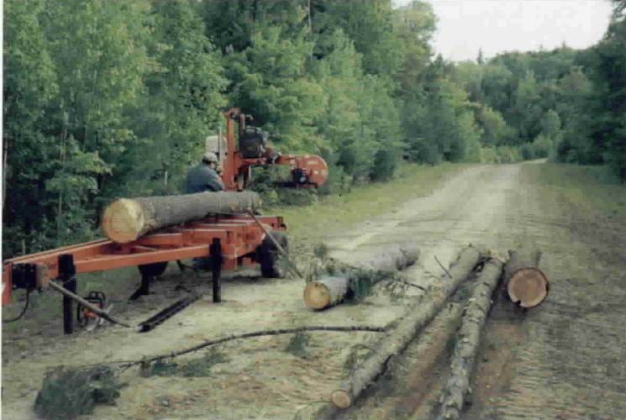
Steve Bennett operating the portable mill
to saw logs for the Trapper Cabin.

New this year at Owl Brook will be the trapper’s cabin built by volunteers from the NH Trapper’s Association. At this time the cabin is complete accept for chinking between the logs. As time progresses the cabin will become more of an educational tool with donated traps, furs, and other equipment or paraphernalia to complete the display. Sean Williamson of NHF&G has kept tract of the volunteer labor expended on this project as it represents a considerable sum in matching funds to NHF&G from the US Sport Fish and Wildlife Restoration Fund. Dwight Pennell, a Carroll County Director of NHTA who lives in Tuftonboro, has served as the Construction Foreman to schedule and direct the many volunteers and coordinate the construction and delivery of donated materials. June 5, 6, 13, and 27 were the four dates thus far, during which the progress to date has been achieved. All that remains to complete the project is the chinking between the logs, which Dwight anticipates will be done during the Rendezvous. Besides the critical position he has played, Dwight also contributed the use of his John Deere tractor to skid out the logs from the Owl Brook property, which were utilized to make the cabin. Other major contributors were Steve Bennett and Karola Owen both NHTA Directors from Epsom who brought their portable saw mill and considerable experience to the Owl Brook site to mill the timber for this project. There were many NHTA Directors, members, and friends of trapping who have pitched in at one or more of the work dates or contributed in other ways to make this project a success. The reward for all this effort will be realized over time as the public passes along the interpretive trails at the Owl Brook facility and the Trappers Cabin becomes one of the significant points of interest to be seen by the countless visitors.
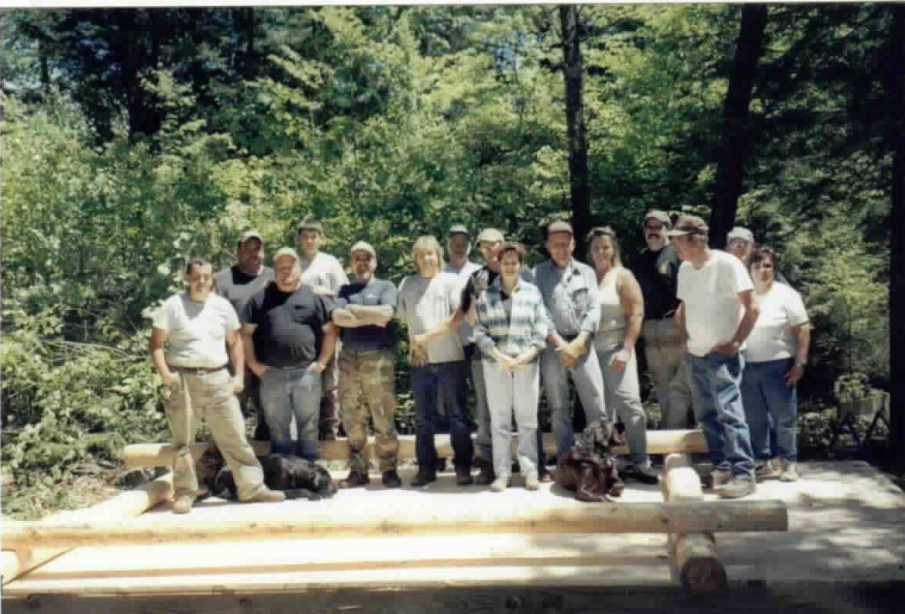
Volunteers who showed up for the first day scheduled on June 5th to get the Trapper Cabin Project started.

