Rambling Along The Trapline 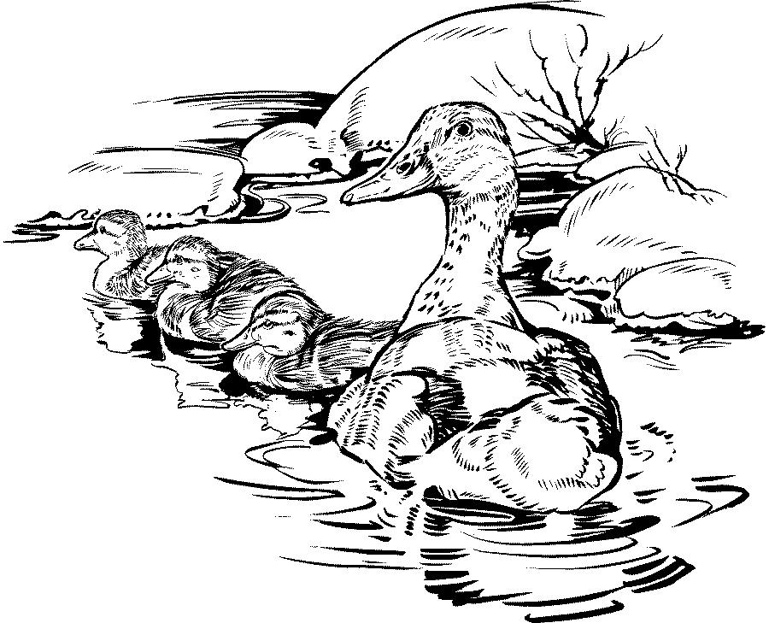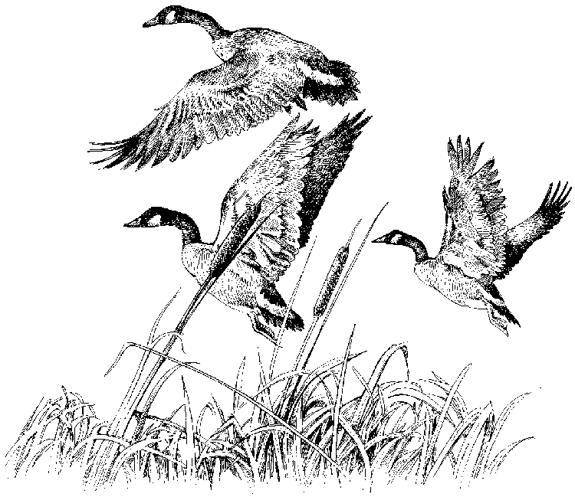
By Mel Liston
Strafford, New Hampshire

Trapping to Benefit Game Birds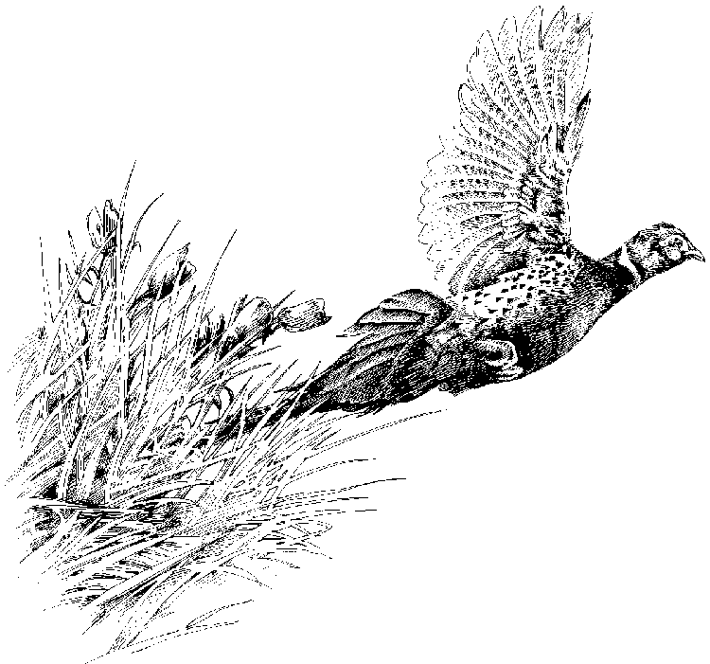

There are a cornucopia of Sportsmen’s/Conservation organizations that center on advocacy of issues and concerns relating to game birds. Three that quickly come to mind are Ducks Unlimited, Ruffed Grouse Society, and the Wild Turkey Federation. All three of these organizations place their emphasis on securing, conserving, and improving habitat primarily to benefit the favored game bird species, which is the center of attention in their sport. Habitat is the most basic component in the business of raising or encouraging game bird species. Regrettably a long effort at primarily emphising habitat has left a lot of adherents somewhat single minded. Many sportsmen’s dollars have been expended to expand and in some cases upgrade habitat but one very important component of wildlife management goes largely overlooked, by that I mean predator management. 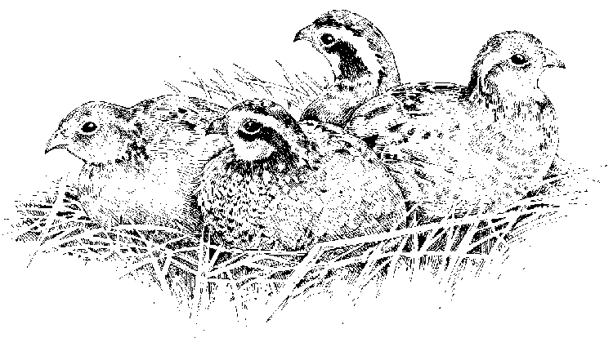
A hypothetical fixed quantity of habitat with a hypothetical fixed quantity of other components such as nesting sites, cover, food, and water, will produce a hypothetical quantity of game birds which can be skewed up or down due to weather extremes. Now whatever this level of production is at Mother Nature’s game farm the whole effort can be diminished considerably if the crop is not protected from predators. Wildlife Biologists keep track of a lot of variables in their efforts to advance science. Science is after all the product of observation in the realm of cause and effect. Yet those who have reason to find the truth are sometimes blinded by other sensibilities, which prevent them from achieving their goal. Science has proven over time that the predator component is a far more serious element than acknowledged, but many Sportsmen/Conservation groups have not embraced this fact. The more expansive the membership, the more likely there will be a constituency within the group that thinks predator management is a non issue or that a non lethal method of control is adequate even if it is not. But the facts are clear, that for a reasonable effort at predator control via trapping there is a significant payback in the form of less overall mortality of game birds. This means more game birds for the sportsmen’s dollars, or higher production from the limited appropriate habitat. There is at least one game bird Sportsman’s/Conservation group that seriously advocates this point of view, and that is Delta Waterfowl. Check out their web site at www.deltawaterfowl.org or call them at 888-987-3695 to find out more about their predator management research. Delta has been funding some of the best research into waterfowl science since it’s inception. Delta is a strong advocate for trapping because the scientific research backs up their contention that trapping is cost effective, and gets the desired results.
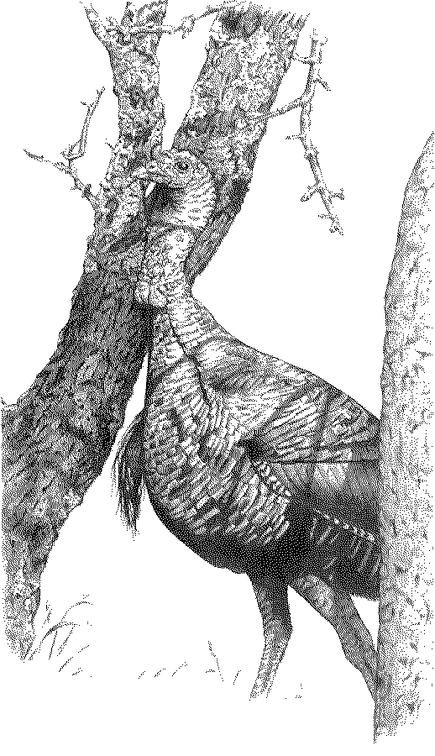
Although the large Sportsmen’s/Conservation groups all occasionally utilize trapping to protect sensitive habitat situations and severely endangered bird species, they do not generally embrace it for the cost effective and efficient tool that it is. If they did, it would be annually incorporated into their management plans. Regrettably this equates to wasted Sportsmen’s dollars. Just how much does it cost to raise a game bird in the wild on appropriate habitat? What is the cost to contributing sportsmen to maintain a large population of predators on a diet of chicks and eggs? Can predator management via trapping make a significant difference in successful game bird production and significantly reduce the cost per bird to the sportsmen? Don’t take your answer from the trapper, check with Delta to benefit from their scientific data and conclusions.
Take some time to study this topic and perhaps you will question if the organizations you belong to are adequately utilizing the trapping tool in their game bird management plan and practice. Perhaps you will see the value for seasonal trapping to manage predator species in the habitat your club manages to benefit game bird species. Perhaps you will become a more vocal advocate for trapping in general.

